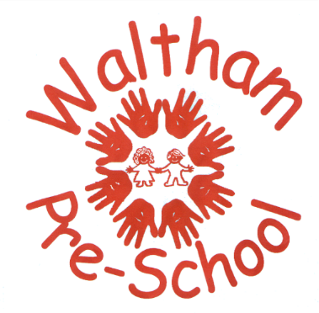

Pupil Allergy Information
Name: |  | D.O.B.
Allergy / Intolerance

Medically Diagnosed Yes No

Are they under Medical Supervision for the Allergy/Intolerance?
(If yes, please give details of what this involves)

Reaction to named foods – signs and symptoms to look out for

Signed: | Date:

