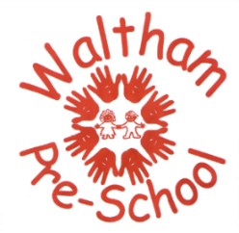 Waltham Pre-School - Parental Contribution

The term Cultural Capital has been added to the new OFSTED Education Inspection Framework
(Sep 2019). The framework states ‘Cultural Capital is the essential knowledge children need to prepare them for their future success’.

Children within our setting all have different experiences during their learning and play. The experiences we offer through the Early Years Foundation Stage and ‘In the Moment Planning’ potentially makes all the difference to each child’s learning journey. It is our role to help the children experience the ‘Awe and Wonder in the World’.

At Pre-school we recognise that all our families are different. We have an ‘All About Me’ section on Tapestry and would appreciate you taking the time to complete this. Additionally, your support in completing this Parental Contribution form would enable your child’s allocated keyperson to use the information on your child’s unique interests to be incorporated into planning and having a more in depth knowledge of your child.

Child’s Name : …………………………………….……………………… D.O.B: ……………………………

Completed by : …………………………………………………………… Date : ………………………...…..

- What does your child enjoy playing with at home ?

- Does your child have any favourite books ?

- Does your child have any interests outside of pre-school ?

- Is there anything which makes your child anxious or upsets them ?

- Does your child have a favourite place, e.g. the park, the beach, shops, etc ?

- Does your child have any pets ?

- Does anything really excite your child ?

- Does your child have any favourite music ?

- What are your child’s favourite foods ?

- Does your child enjoy any family activities, e.g. baking ?

Is there anything else that you would like to add that would support your child’s interests ?

Thank you

